AM:> live-server dir[notes-app]

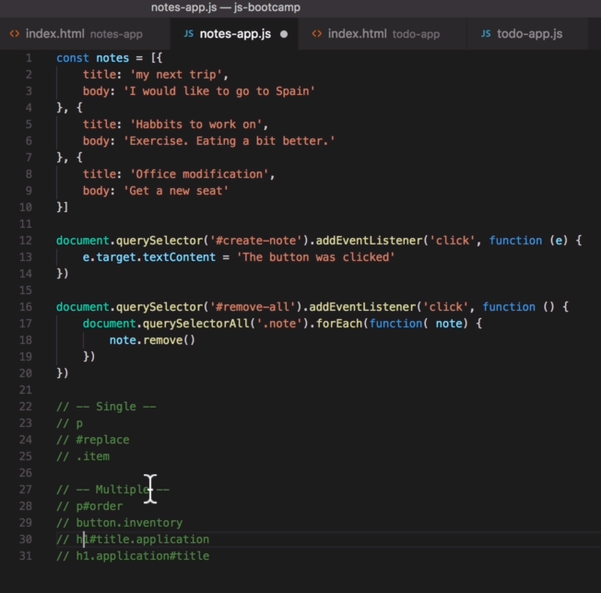

Lesson 71:

location.assign('/edit.html') - back to edit.html

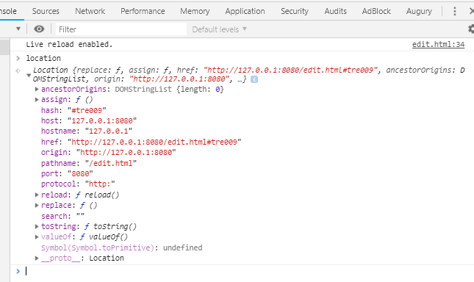

location.hash

location.hash.substring(1)

location.hash.substring(1, 4)